The Draft
Day 1:
You will be assigned a group
You will find one person who represents that category. Ex: https://www.huffingtonpost.com/thom-nickels/conscientious-objector_b_4029879.html

You will make a small poster of that person to put on the larger poster. Sample:
Conscientious Objectors of Vietnam
(Your group will come up with an interesting title for your sign
Thom Nickels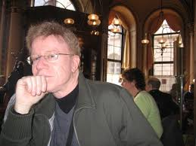
Here you write their story, in your own words, using first person (I, me, my). The story should be four or more paragraphs

